**Sumita Jain**

**Week 1 Homework: Excel Challenge (Kickstarter)**

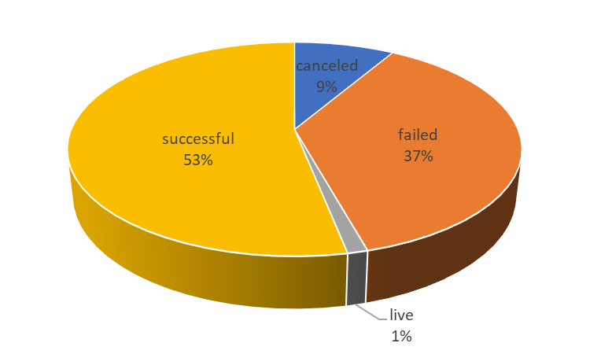This report summarizes findings from an analysis of 4,114 individual Kickstarter projects launched in 21 countries between May 2009 and March 2017. Fifty (1%) of these projects were ongoing at the time of data collection. The pie chart illustrates the status of the projects studied. Overall, just over half of the projects were successful.

**Figure 1: Project Status**

The projects span nine categories. The stacked column chart below shows that about a third of the projects launched are from the “theater” category; in total, four categories account for 78% of all projects studied: theater, music, technology, and film & video. The chart also shows that the proportion of successful projects for music, theater, and film & video is significantly higher than that for the remaining categories of projects.

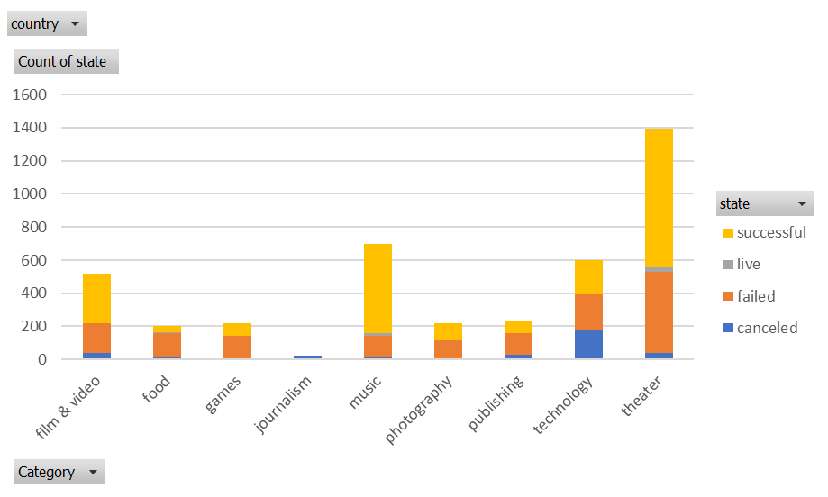

**Figure 2: Project status by Category**

The nine project categories are comprised of 41 subcategories. The stacked column chart below shows that ‘plays,’ which is a subcategory under the ‘theater’ category, comprises roughly a quarter of all projects studied (1,066). 694 or two-thirds of these ‘plays’ projects were successful – this makes the ‘plays’ subcategory the most successful one in this dataset. ‘Rock’ is a distant second subcategory with 260 projects launched. It’s noteworthy that all 260 ‘rock’ projects were successful. The chart shows that 11 other subcategories also had a 100% success rate for all projects launched.

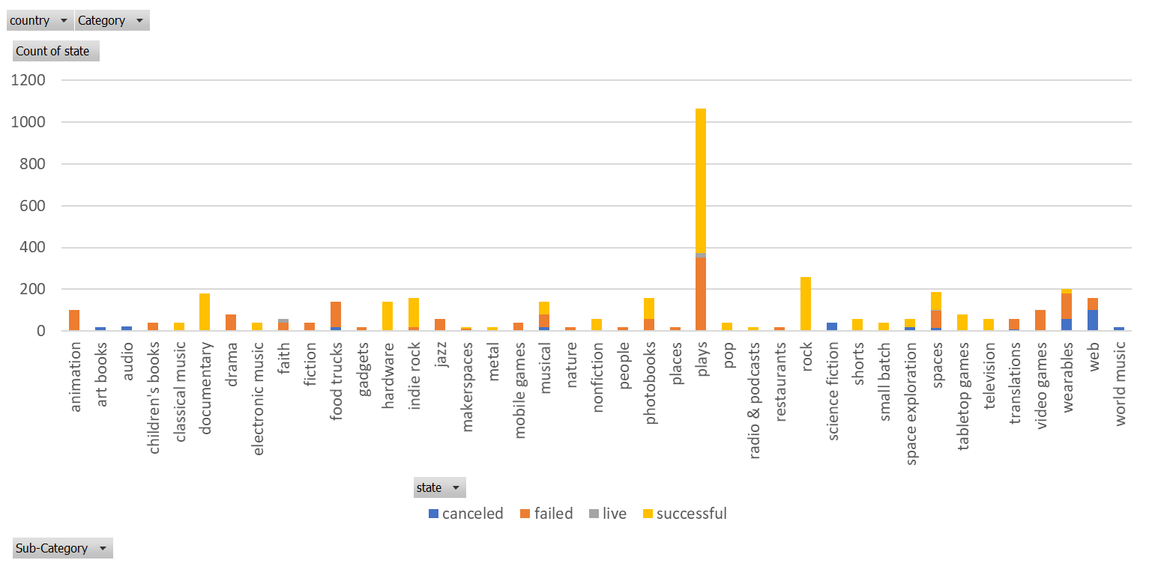

**Figure 3: Project status by Subcategory**

The status of project launched at different times of the year is shown in the following line graph. The data shows no particular seasonal effect.

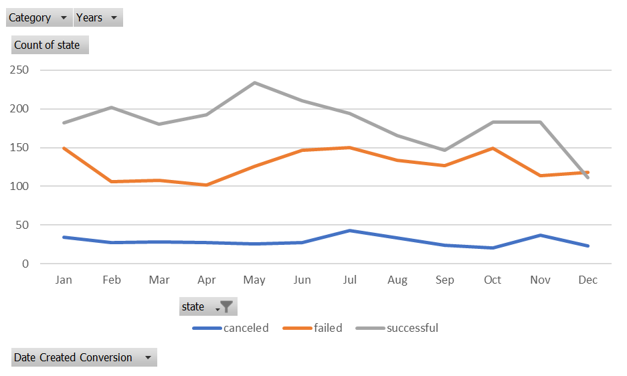

**Figure 4: Projects launched**

**In summary:**

1. **Given the provided data, what are three conclusions we can draw about Kickstarter campaigns?**
   * 1. Only about half of the projects initiated were successful.
     2. According to the dataset, more ‘theater’ projects were initiated during the 2009-2017 period of analysis than any other category of projects.
     3. The subcategory with the most projects launched is ‘plays.’ Roughly two-thirds of these projects were successful in gaining funding.
2. **What are some limitations of this dataset?**
   * 1. The dataset’s provenance is unclear; thus, it is not possible to know whether the data is complete. In other words, there is a possibility that more than 4,114 Kickstarter projects were initiated during the period of analysis and the data provider extracted a subset of the complete dataset using their own specific (unknown to us) filters. If the data set is neither complete, nor a random sample of statistically significant size, the conclusions drawn from the analysis should not be used for decision making.
     2. There is a lack of documentation regarding the meaning of different fields. Therefore, some possibly important fields (e.g., spotlight, staff pick) were not analyzable.
3. **What are some other possible tables and/or graphs that we could create?**
   * 1. Graphs showing the relationship between the number of backers or the size of donations with the success of a project.
     2. Graphs showing the trend of percent of all projects that were successful over time (years), by category and subcategory.